PAMAC Centre Seal Process Manual to add New PAMAC Centre Seal Image

1) PMS Login →Organization Tree → Master → Master → Master

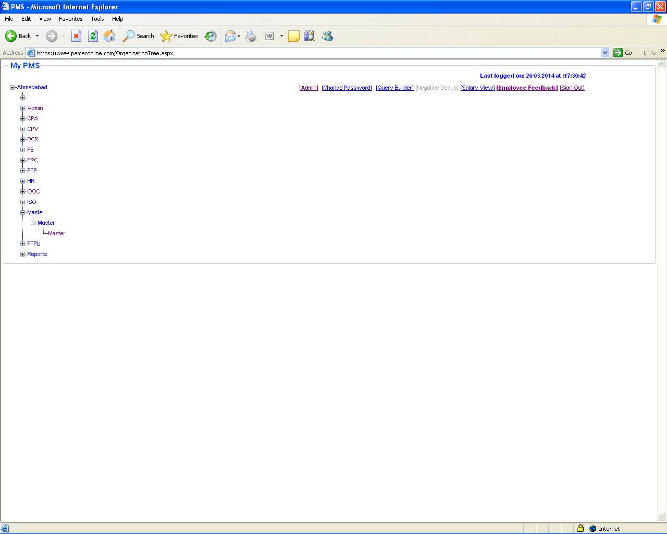
2) Admin → Centre Pamac Seal

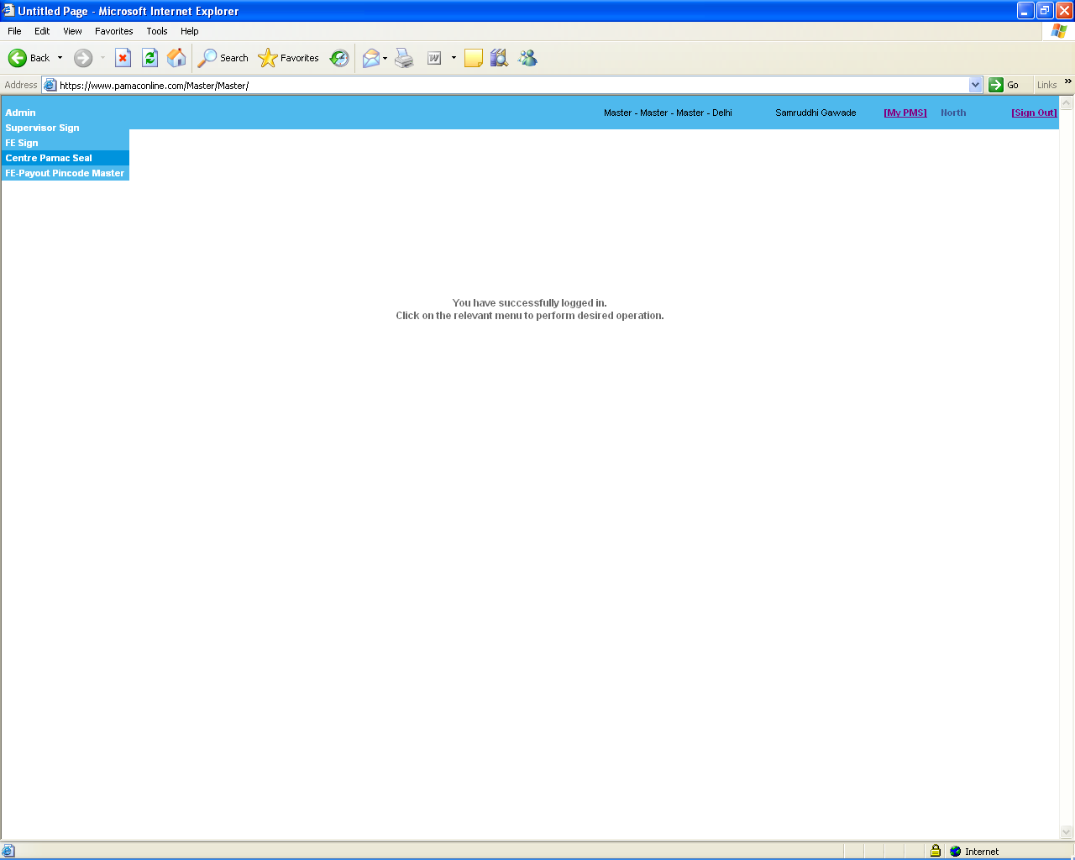
3) User can add PAMAC Centre Seal by filling all the details as shown below.

- Centre Search: Enter centre name in the textbox -> Click “GO” button. All the related names of centers will appear in the “Centre Name” dropdown list.

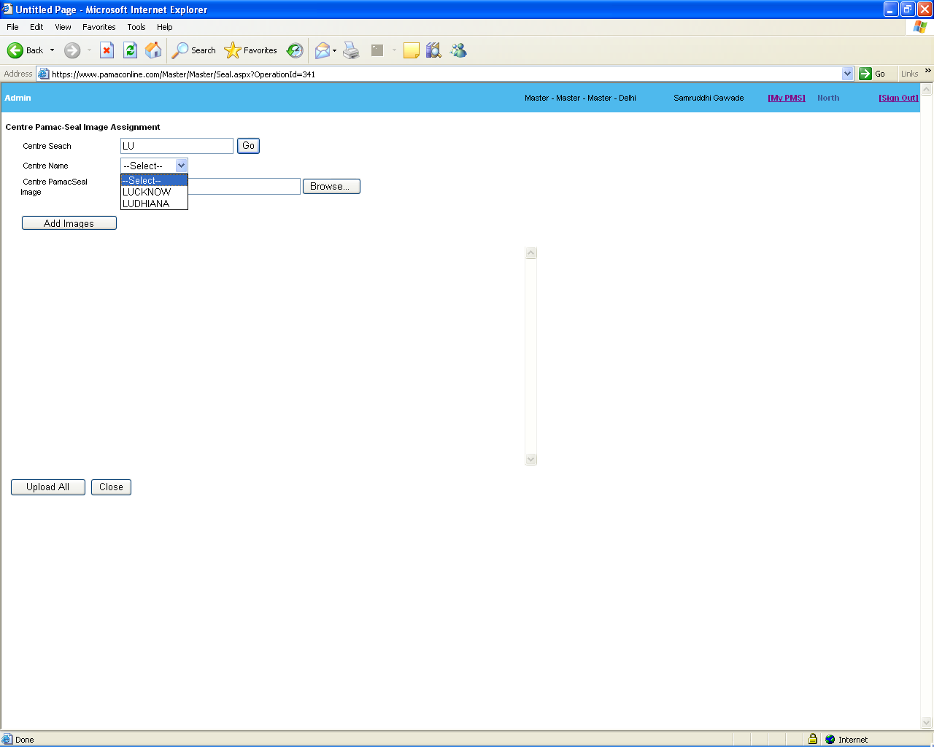
4) To add PAMAC Centre Seal.
- Select name of center from “Centre Name” dropdown list.
- Add PAMAC Centre Seal Image from “Centre PamacSeal Image” attachment option.
- Click on “Add Images” button to add PAMAC Centre Seal image.
- Click “Upload All” button to add the centre seal.

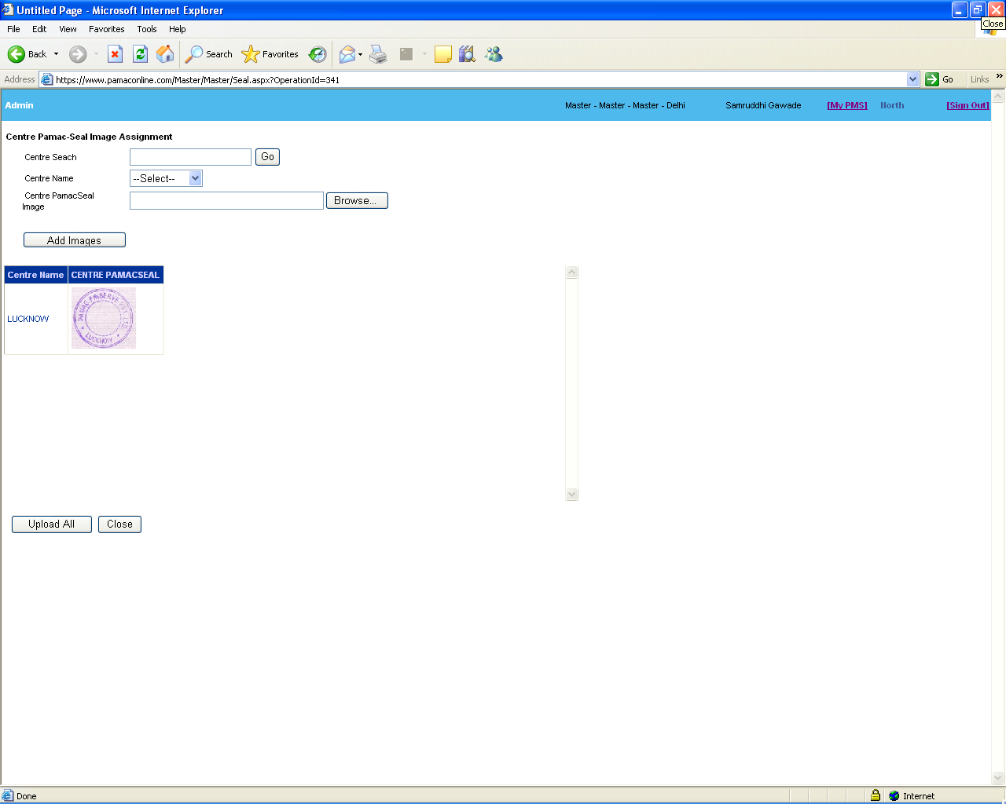
5) To add multiple PAMAC Centre Seals at single time.
- Select name of center from “Centre Name” dropdown list.
- Add PAMAC Centre Seal Image from “Centre PamacSeal Image” attachment option.
- Click on “Add Images” button to add PAMAC Centre Seal image for particular location.
- Follow the same process to add PAMAC Centre Seal Image for another location.

- Click “Upload All” button to add all the PAMAC Centre Seals.

